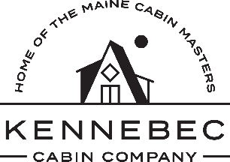

New Vendor Form

**Please print and mail to:**

Kennebec Cabin Company

Attn: New Product Review Team

915 Western Ave.

Manchester, ME 04351

Date:

Company/Artist Name:

Company/Artist Website:

Contact Name:

Contact Address:

Contact Phone Number:

Contact Email:

EIN Number:

Item(s) description. Please include wholesale & suggested retail pricing.

**Please Check One**:

Picture(s) Included – If checked, how many pictures are included?

Sample(s) Included – If checked, please list the samples.

*Please let us know if you would like samples returned to you. You must either pick up at the Kennebec Cabin Company or include return postage.*